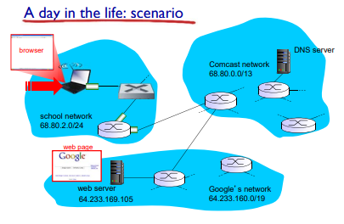

* 1st Protocol - DHCP(application layer)
  + Gets IP address for laptop
  + Open web browser
    - Contact google server. DNS gives the website domain name.

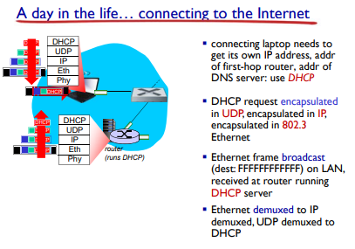

* This request gets sent using a broadcast.

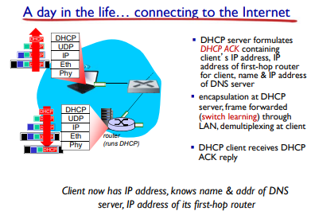

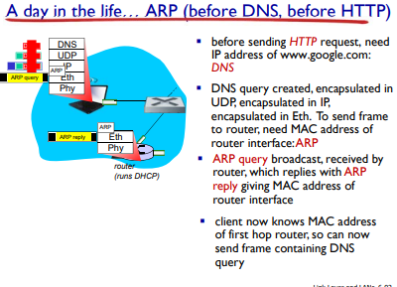

DNS using UDP in the transport layer when sending back to user.

ARP - translation

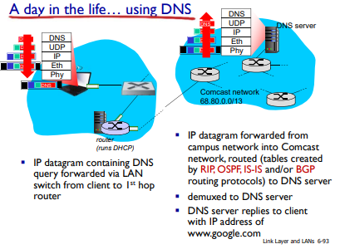

Intra Routing Protocol -

Inter Routing Protocol -

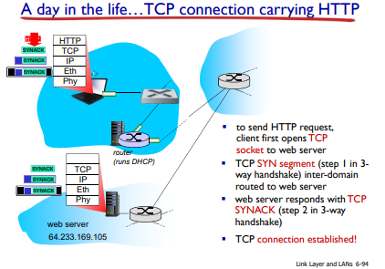

1st step of tcp: build connection (project 1)

To send http request: client opens tcp socket to web server

Three-way handshake: Send SYN bit > server responds

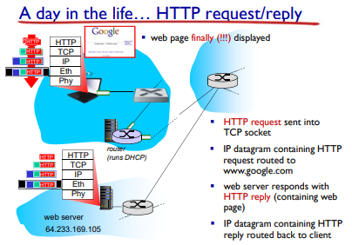

green:HTTP Port number: 80

Blue: google server IP from DNS server

BLack: MAC address of first hop router